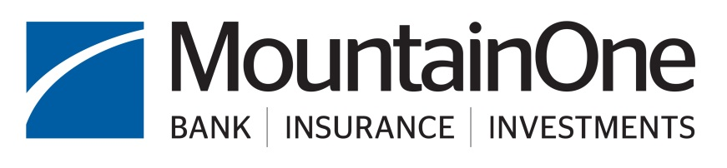

Community Dividend Application Instructions

MountainOne is proud to support the communities we serve by giving back –
a dividend for all you do to support us throughout the year!

We fund a wide variety of community programs, especially those related to:

- Affordable Housing
- Small business and economic development
- Veterans’ services
- Individuals with disabilities
- Education and financial literacy
- Youth sports and activities
- Arts and culture
- Other community needs

Funding preference is given to organizations or specific not for profit programs supporting small businesses or low-to-moderate income individuals and families.

Application Guidance:
- Your organization may apply once per calendar year. Please be sure to consider all needs for the calendar year when you apply, including event sponsorships, galas, programs, ads and other support.
- Your organization should not apply separately to other MountainOne divisions or to multiple individuals, departments, or branches. The Community Dividend program is the funding source for all MountainOne companies.
- Application submission deadlines are February 1, May 1, August 1, and November 1. All Hunger Relief programs are reviewed in the November round. Please plan your requests to be part of one of the funding reviews above.
- Donations vary, but typically range from $25 - $2,500. Requests should reflect careful consideration of need of your organization for the entire calendar year. Please provide several funding options/scenarios for consideration.
- Any request for over $500 must complete the following Community Dividend application. Requests $500 or below may contact Community Engagement for instructions. Organizations may not make multiple requests in a calendar year, no matter the amount.
- MountainOne funds programs that are located in, or substantially benefit our served markets of North Adams, Pittsfield, Williamstown, Quincy, Rockland, Scituate, and immediate surrounding areas.
- Donations should not be considered to be automatically renewable unless there is a written multi-year commitment. Organizations should reapply each calendar year in plenty of time for any sponsored events and related publicity. Please only include events or programs for the current calendar year.
- Submit application and all supporting documentation as a single PDF file. Please do not send .zip files or Google (or other cloud-based) documents. Do not include confidential information, including customer status.
- The following are not eligible to apply for funding:
  - Individuals, including fundraising for educational trips on an individual basis
  - National fundraising organizations or programs
  - Professional or 3rd party fundraisers that receive a commission based on donation
  - Religious organizations without a related charitable or cultural purpose
  - Political organizations, politically motivated causes, lobbying groups, or political campaigns

Please email your completed application to us at community@mountainone.com.

Community Dividend Application

- Name of Organization: Click here to enter text.

- Mailing Address: Click here to enter text.

- Physical Address: Click here to enter text.

- Name of Executive Director: Click here to enter text.

- Name, title and email of individual to contact regarding this application:
Click here to enter text.

- Please write out the mission statement of your organization.
Click here to enter text.

- Area primarily served: (you may choose more than 1)

☐North Adams
☐Pittsfield
☐Williamstown
☐Berkshire County Region
☐Quincy
☐Rockland
☐Scituate
☐South Shore Region

- Briefly explain the nature of your program – in 100 words or less. Indicate who benefits, what services are provided, where those services are provided, and any general information about your organization.
Click here to enter text.

- What percentage of the people served by your organization or a specific program within your organization are in the low-to moderate income bracket or are small businesses? If it is 50% or more, please briefly outline your procedure for documenting this. Do not provide individual personal information, but rather overall information as it pertains to your specific program. Funding preference is given to organizations or programs serving low-to-moderate income individuals and families.
☐Less than 50% low-to-moderate income
☐More than 50% low-to-moderate income: please provide percentage and method of calculating: Click here to enter text.
☐This application is for a school that has more than 50% of its students receiving free or reduced lunch. Please provide percentage and link to current year data on DESE website: Click here to enter text.
☐This application is for a school district designated as a federal free lunch district.
☐This application is for a program supporting economic development, economic recovery, small business development or technical support to small businesses.
☐This program does not track or document income.
☐Other – please provide details: Click here to enter text.

- What is the dollar amount of your request for funding? Please explain how the funds will be used.
Important - Please note: Donations vary, but typically range from $25 - $2,500. Requests should reflect careful consideration of the needs of your organization or program for the full year, and only for events and programs occurring this calendar year. Please include requests for all programs, ads, events, galas, tournaments, donations, etc. in one application. Please provide several funding options/scenarios for consideration, and include any recognition provided to supporters. Your organization may only apply once per calendar year no matter the amount.
Click here to enter text.

- Does anyone affiliated with MountainOne volunteer for your agency? (Board, Committee, Fundraising, Events, Member, etc.) Please list their name and explain their role with your agency:
Click here to enter text.

- Please list your Board of Directors, their position on your Board, and their professional affiliations. Please list here and do not attach additional materials.

Board Member Names | Board Role (Chair, Director, etc.) | Professional affiliation
Click here to enter text. | Click here to enter text. | Click here to enter text.

- What is the total annual budget of your organization or the specific program you are applying for? Please just include a single dollar amount and brief explanation. Do not attach a separate budget. We do not generally fund operating costs such as salaries.
Click here to enter text.

- MountainOne prefers not to be the sole funder of a project or organization and in general does not provide operating funds for an organization. To that end, please list your significant funding sources, amounts, and other large requests pending:
Click here to enter text.

- What was the total dollar amount of support provided by MountainOne in the prior calendar year? What program did it support?:
Click here to enter text.

- Is your organization tax-exempt under IRS 501(c)(3) or similar status?
☐Yes ☐No
If Yes – Submit your valid tax-exempt certificate attached to this application as a single PDF.
If No – Do you have a designated fiscal agent that can accept donations on your behalf? MountainOne does not generally donate to organizations that do not have an official charitable status.
Click here to enter text.

Define the dollar amount of the requested donation that would not be eligible for tax exemption (if any.)
Click here to enter text.

